Here is an experiment for your SA

1. Terminate SA port with a 50R terminator – no cables no external attenuation
2. Turn off all internal attenuation
3. Set the center frequency to 7 MHz
4. Set the span (SPAN button) to 1 Khz
5. Set the bandwidth resolution (BW button) and video resolution to 1 Hz..its will be a slow sweep
6. Set the reference level (AMP Button) to -100 so that you can see the trace ensure preamp is off

Here is what I see

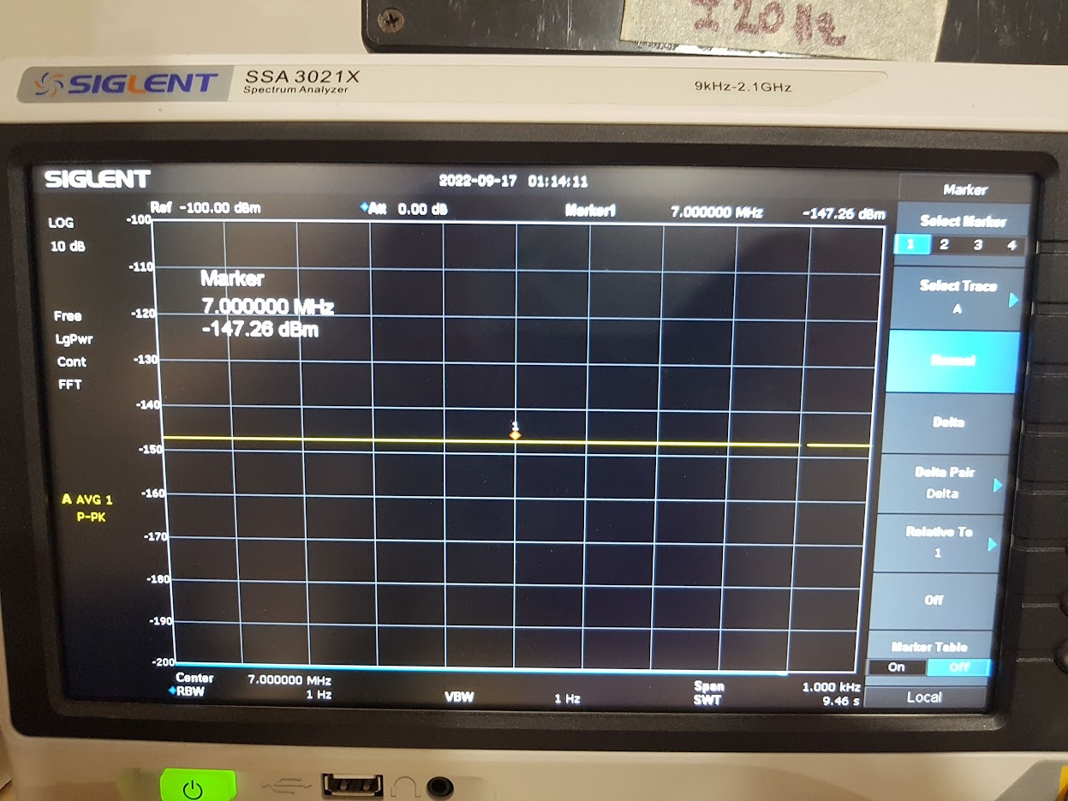

I think this is the internal noise floor of the SA. The SA cannot resolve a noise floor below this or a signal below this level without the preamp turned on.

1. Next set internal attenuation to 10 db (AMP button)

This is what I see…noise floor goes up 10 dB to 137 dBm

1. Next set internal attenuation to 30 db (AMP button)

This is what I see…noise floor goes up 30 dB to -117 dBm

1. Install an external attenuator (any value 10 or 20 dB)
2. Next set internal attenuation back to to 0 db (AMP button)

This is what I see…NO CHANGE in noise floor! You can see my external attenuation in the picture

1. I installed a second terminator for 40dB of attenuation

This is what I see…NO CHANGE in noise floor! You can see my external attenuators in the picture

1. Now with no external attenuation and terminator….port is open (don’t do this for long). You can see my port is open circuit.

**Observation 1: Cool…so the internal attenuation impacts the noise floor**

1. Go back and install external attenuator – just to be safe. No stray signals leak into SA.
2. Set resolution bandwith (BW Button) to 10 Hz.
3. Set average to 200 (Trace Button)
4. Adjust reference level to move trace (AMP Button)

This is what I see. The noise floor has come up 10dB!! Cool

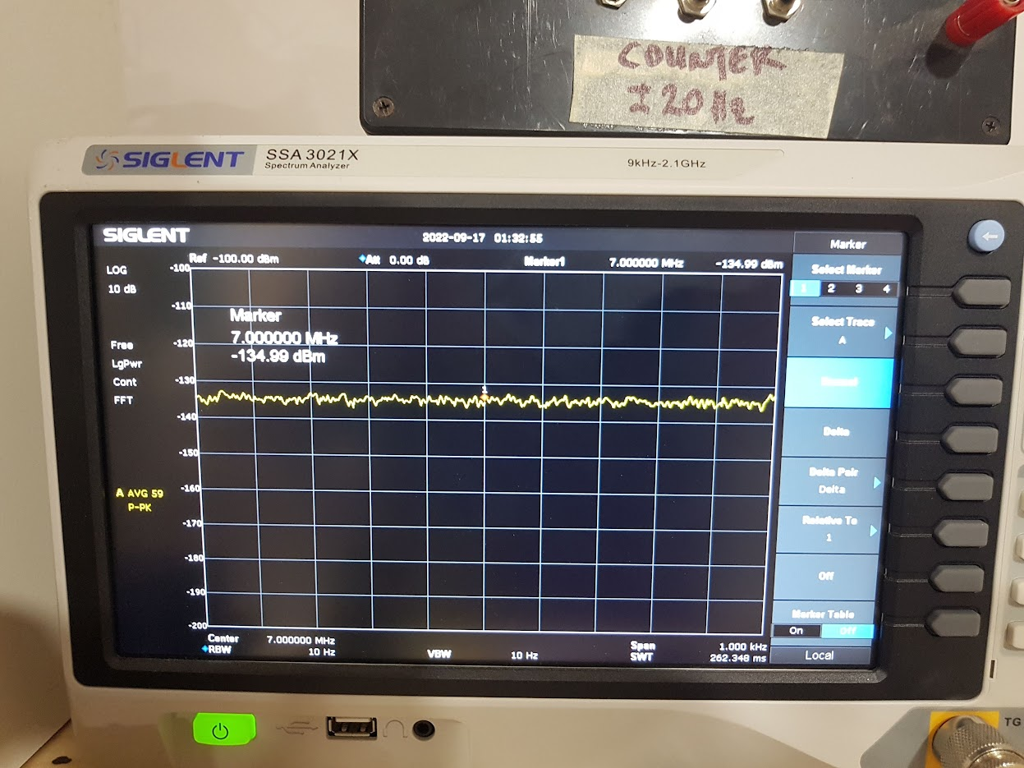

1. Set span to 100 KHz (SPAN Button)
2. Adjust reference level to move trace (AMP Button)

This is what I see. The noise floor has come up 20dB!! Very Cool

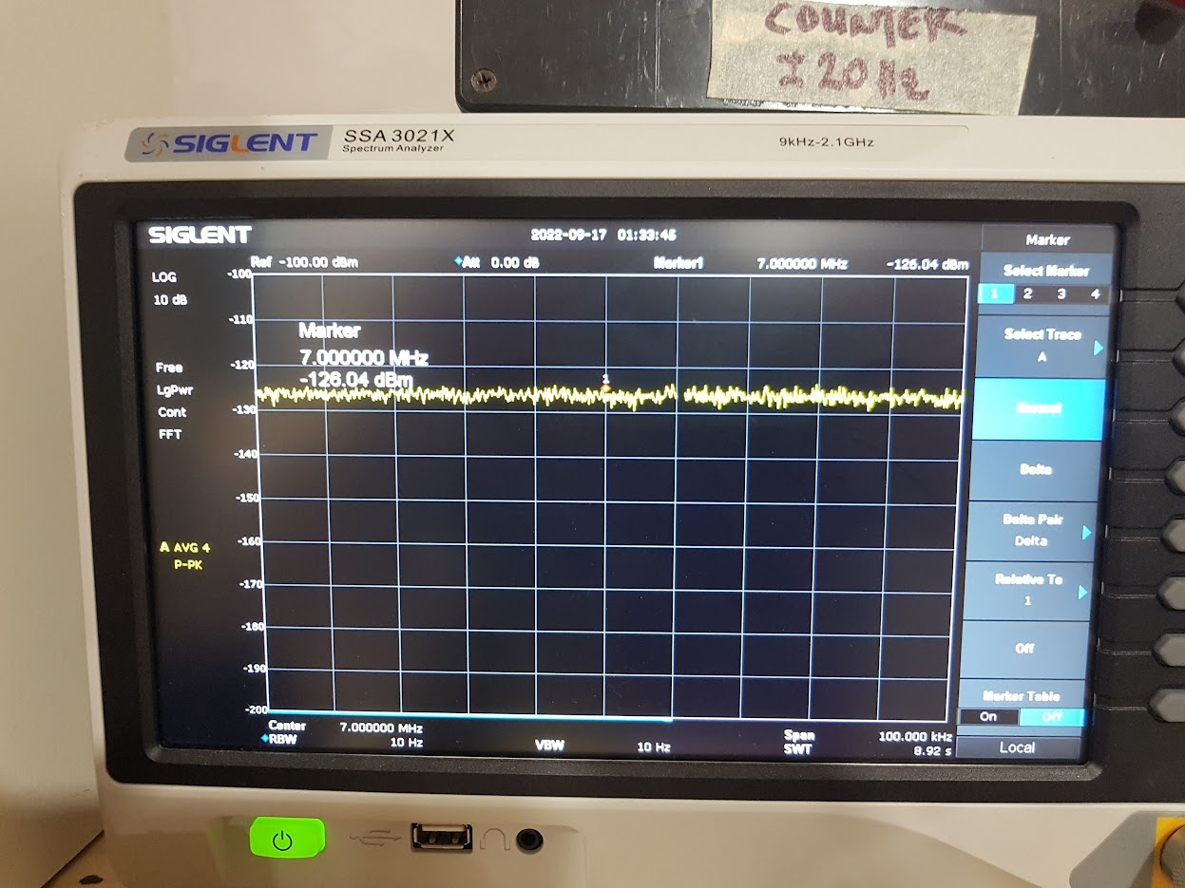

1. Keep span the same
2. Adjust resolution bandwidth to 100 Hz
3. Adjust reference level to move trace (AMP Button)

This is what I see. The noise floor has come up 20dB!! Very Cool

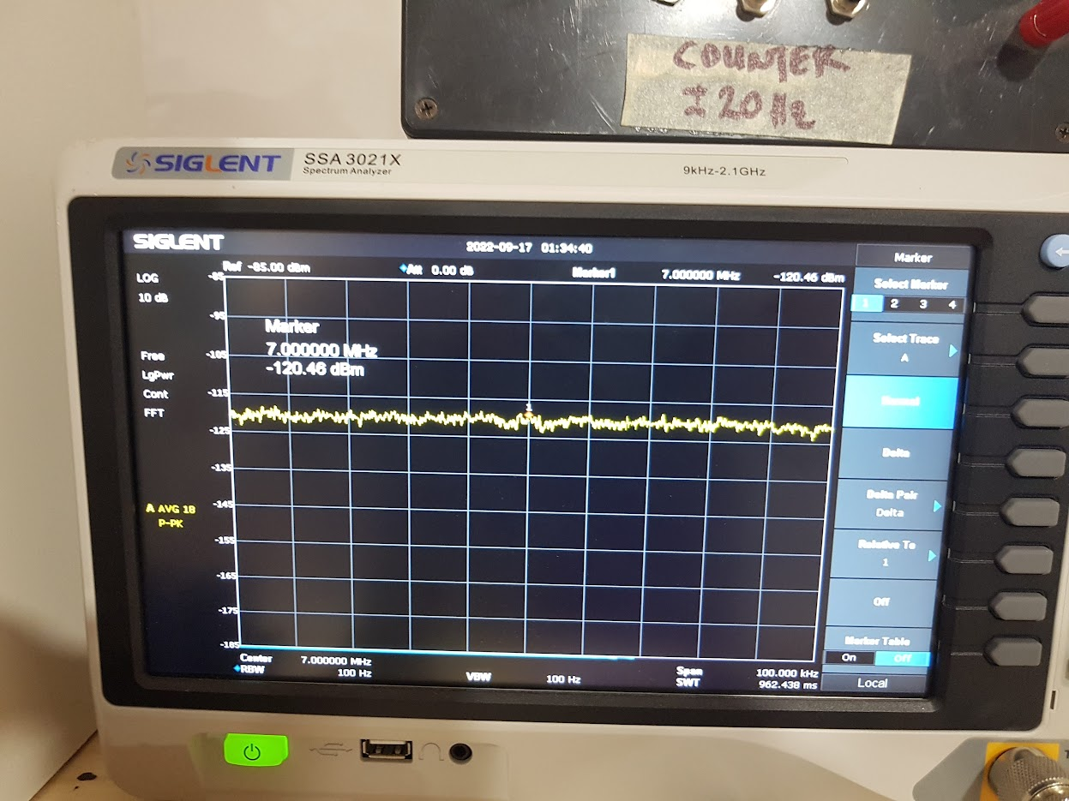

The extreme is now to power off and on your SA and look at the noise floor of the default settings. Test question…why is it this high?

**Observation 2: Friggen VERY cool…resolution also impacts the noise floor**

This is why we cannot get a accurate noise floor reading with our SA. Both internal resolution and internal attenuation impacts the noise floor.

If the repeat the same (with external attenuation) with Sig Gen you will get a maximum noise floor which stays the same even if an amplifier is inserted.

This is another lesson why you need to always do an apples-to-apples comparison. I.e., don’t change setting on SA for relative measurements.

With the LBS amp, I cannot get the noise floor to move from -137 dBm. i.e., if I connect the SA directly to my Siglent Sig Gen with 40 dB of external attenuation the noise floor is -137 dBm. If I connect the LBS amp between sig gen and SA, I still get -137 dBm (with external attenuation of course!!). Note that we proved above that external attenuation does not impact the noise floor of the SA.